**Examples:**

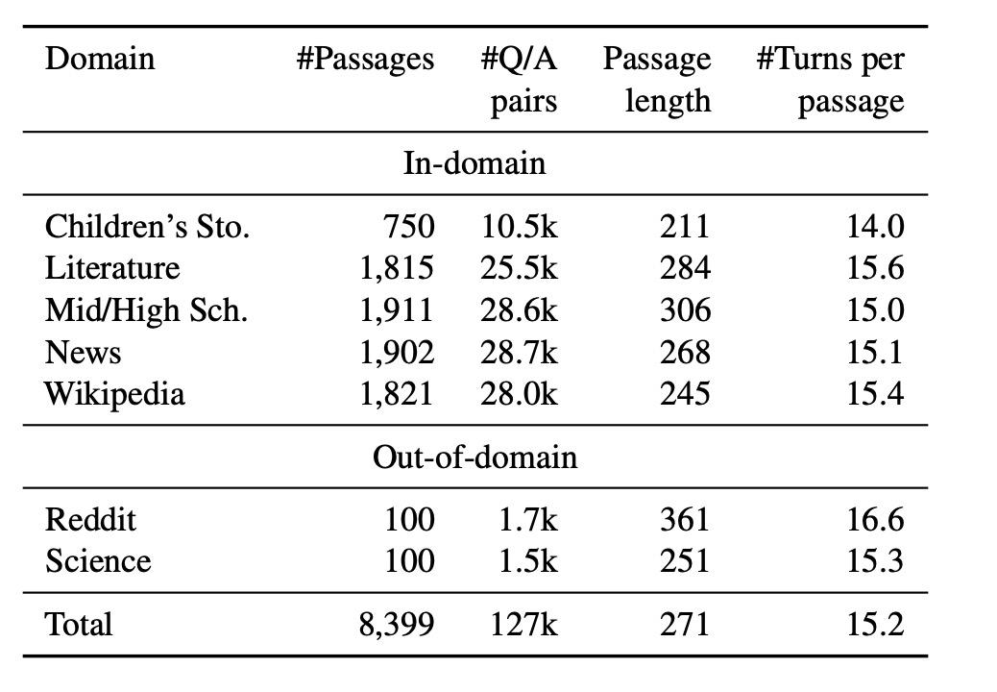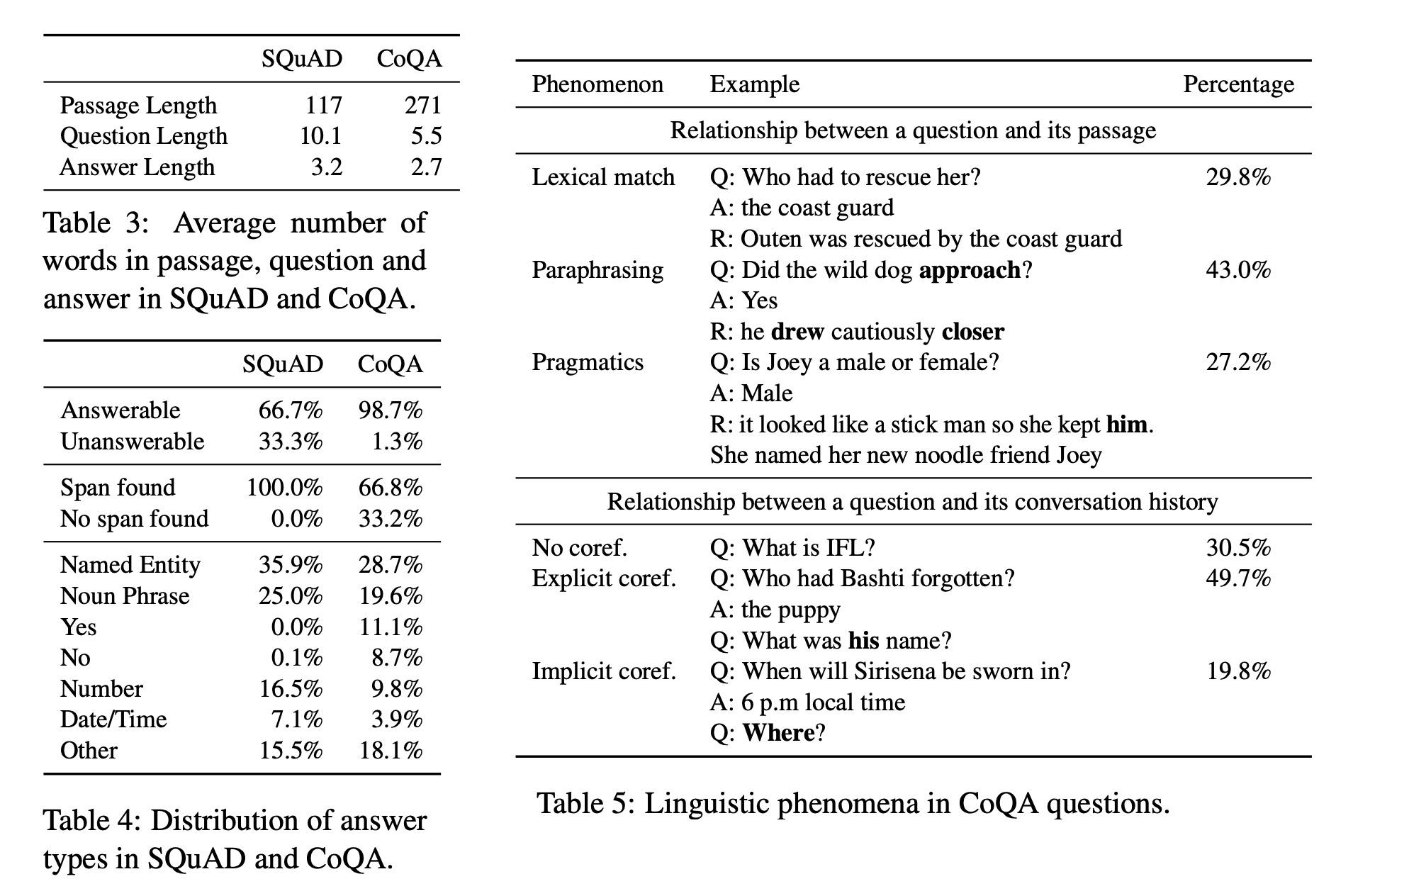

**Some Rudimentary Analysis:**

Total number of documents: 5326

Number of usable documents: 4611

Number of unusable documents: 715

1. Overall:

| Total # of documents | # of usable documents | # of unusable documents |
| --- | --- | --- |
| 5326 | 4611 | 715 |

Overall Statistics For Exposition Length

Exposition Max Length: 7836.0

Exposition Min Length: 14.0

Exposition Mean Length: 3066

Exposition Standard Deviation: 1075

1. Exposition Length

| Max | Min | Mean | SD |
| --- | --- | --- | --- |
| 7836 | 14 | 3066 | 1075 |

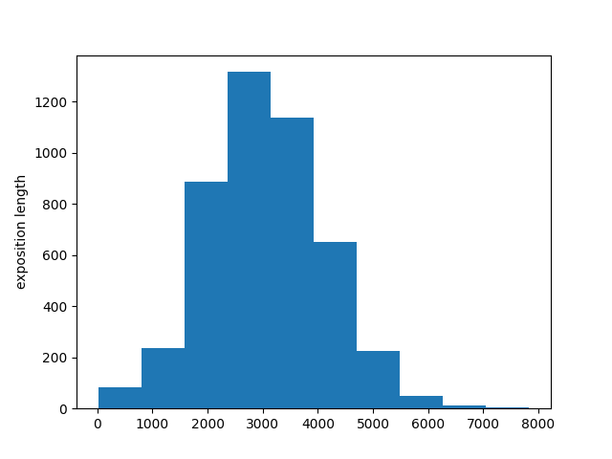

1. Q&A Session

|  | Max | Min | Mean | SD |
| --- | --- | --- | --- | --- |
| # of Questions | 57 | 1 | 14.24 | 8.22 |
| Length of Q | 1690 | 3 | 332.11 | 177.73 |

Overall Statistics For Number of Questions

Max Length: 57.0

Min Length: 1.0

Mean Length: 14.23769247451746

Standard Deviation: 8.219941911787824

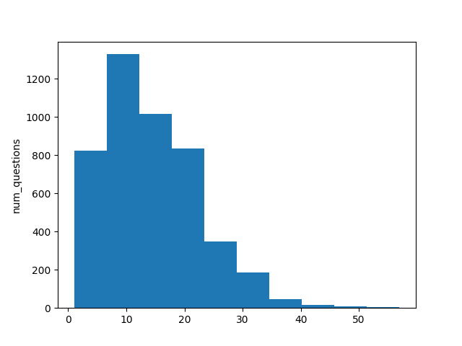

Overall Statistics for Question Length (Unweighted):

Length of Questions Max Length: 1690

Length of QuestionsMin Length: 3

Length of Questions Mean Length: 332.1114851485149

Length of Questions Standard Deviation: 177.73479944668077

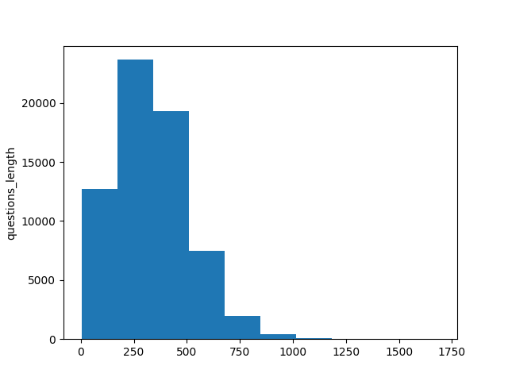

Table of Statistics

Overall:

| Total # of documents | # of usable documents | # of unusable documents |
| --- | --- | --- |
| 5326 | 4611 | 715 |

Exposition Session

|  | Max | Min | Mean | SD |
| --- | --- | --- | --- | --- |
| Length of Expo | 7836 | 14 | 3066 | 1075 |

Q&A Session

|  | Max | Min | Mean | SD |
| --- | --- | --- | --- | --- |
| # of Questions | 57 | 1 | 14.24 | 8.22 |
| Length of Q | 1690 | 3 | 332.11 | 177.73 |

| Name of Company | Newmont Mining Corp | American Express | Huntington Ingalls Industries | Google | Total |
| --- | --- | --- | --- | --- | --- |
| Type of Company | Mining | Finance | Shipping | Tech | - |
| Total questions asks | 22 | 14 | 29 | 18 | 83 |
| Clarification questions | 13 | 8 | 18 | 13 | 52 |
| Challenge Questions | 3 | 4 | 10 | 4 | 21 |
| Presupposed Questions | 6 | 2 | 1 | 1 | 10 |

| Name of Company | Newmont Mining Corp | American Express | Huntington Ingalls Industries | Google | Total |
| --- | --- | --- | --- | --- | --- |
| Type of Company | Mining | Finance | Shipping | Tech | - |
| Product questions | 9 | 8 | 10 | 10 | 37 |
| Management questions | 4 | 3 | 12 | 4 | 23 |
| Finance Questions | 2 | 3 | 5 | 2 | 12 |
| Ethics Questions | 0 | 0 | 2 | 2 | 4 |
| ESG | 7 | 0 | 0 | 0 | 7 |